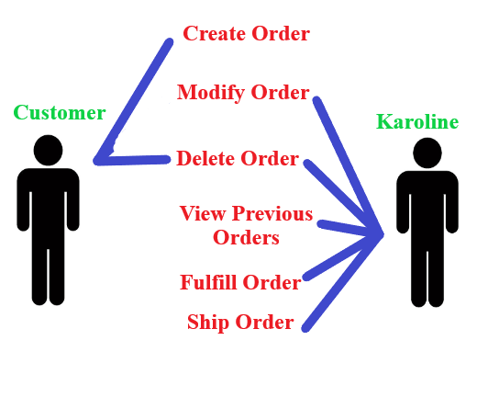

Order Diagram

The above diagram illustrates the interactions between a customer and Karoline when engaging in multiple use cases involving a customer order. It is to be concluded that the customer may create and delete their own order and any modifications must be done by contacting Karoline. Karoline may modify, delete, fulfill, and ship an order as well as view any previous orders.